**Development of Disaster recovery with IBM Cloud virtual:**

**Developing a disaster recovery plan with IBM Cloud Virtual Servers involves several key steps. Here's an overview of the process:**

**1.** **Assessment and Planning:**

- Identify critical data and applications that need to be protected.

- Determine recovery time objectives (RTO) and recovery point objectives (RPO) for these resources.

- Decide on the appropriate IBM Cloud Virtual Server configurations for your primary and recovery sites.

2. **Backup and Replication:**

- Implement regular backups of your data and server configurations.

- Set up data replication to a secondary IBM Cloud Virtual Server or another location to ensure data redundancy.

3. **Failover and Failback Procedures**:

- Create a documented procedure for initiating failover to the secondary site in case of a disaster.

- Define the steps for failing back to the primary site once it's restored.

4. **Network Configuration:**

- Ensure proper network connectivity between the primary and secondary sites.

- Use VPNs or Direct Link to establish secure communication between sites.

5. **Monitoring and Testing:**

- Implement monitoring tools to continuously track the health of your primary and secondary resources.

- Regularly test your disaster recovery plan to ensure it works as expected.

6. **Automation**:

- Use automation tools to streamline failover and failback processes, reducing manual intervention.

7. **IBM Cloud Services:**

- Leverage IBM Cloud services like IBM Cloud Virtual Servers, IBM Cloud Object Storage, and IBM Cloud Databases to support your disaster recovery strategy.

8. **Data Encryption and Security:**

- Implement encryption for data in transit and at rest to ensure security.

9. **Documentation:**

- Maintain comprehensive documentation of your disaster recovery plan, including contact information for team members and third-party service providers.

10. **Compliance and Regulations:**

- Ensure that your disaster recovery plan complies with any industry-specific regulations and standards.

11. **Regular Updates and Training:**

- Keep your disaster recovery plan up to date with changes in your infrastructure.

- Train your team on the procedures and ensure they are familiar with their roles during a disaster.

12. **Third-Party Solutions:**

- Consider using third-party disaster recovery solutions that are compatible with IBM Cloud, such as Veeam, Zerto, or IBM Resiliency Orchestration.

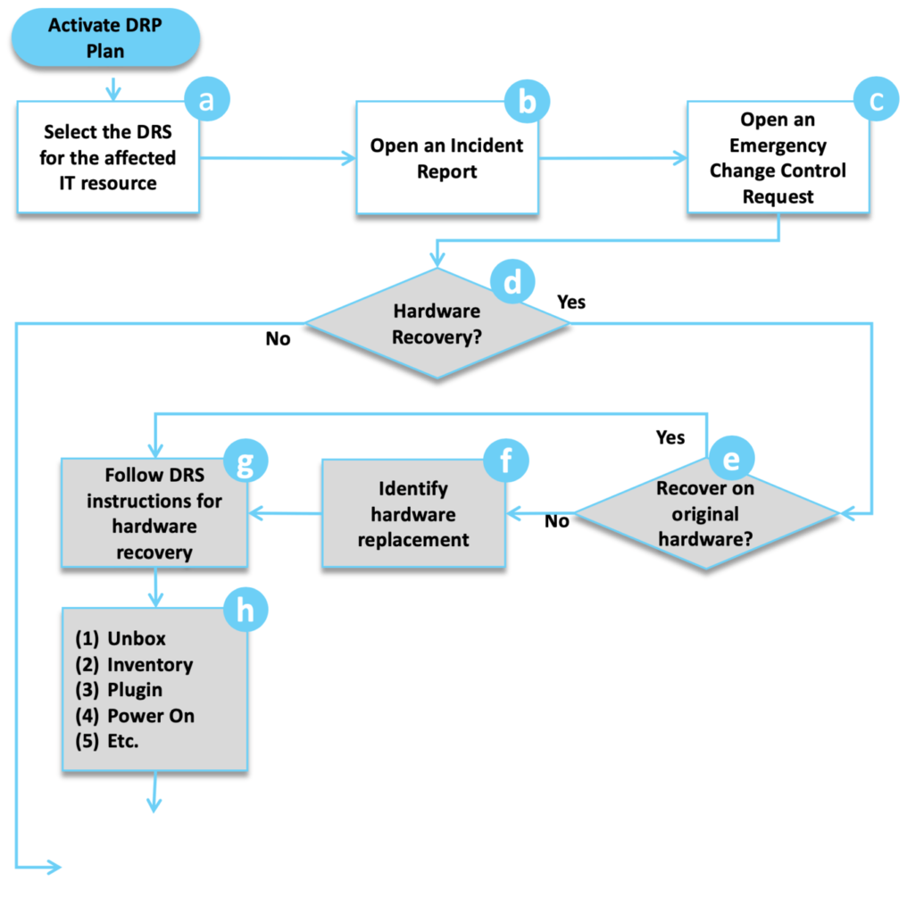

**Needs of the disaster recovery with IBM Cloud virtual**

1. **Assessment and Planning**:

- Identify critical applications and data that need protection.

- Define recovery time objectives (RTO) and recovery point objectives (RPO) to determine how quickly you need to recover and how much data loss is acceptable.

2. **Select IBM Cloud Virtual Servers**:

- Choose the appropriate virtual server configurations based on your requirements.

3. **Data Replication**:

- Implement data replication mechanisms to keep data synchronized between your primary and secondary sites. IBM Cloud offers solutions like IBM Cloud Object Storage and IBM Cloud Block Storage for data replication.

4. **Failover Site**:

- Set up a secondary site in a different geographical region to minimize the risk of a regional disaster affecting both sites.

5. **Automated Failover**:

- Implement automated failover processes to minimize manual intervention during disaster recovery. IBM Cloud services can help with automation and orchestration.

6. **Testing and Validation**:

- Regularly test your disaster recovery plan to ensure it works as expected. This includes testing failover and failback procedures.

7. **Monitoring and Alerting**:

- Implement monitoring and alerting systems to detect issues in real-time and trigger failover when necessary.

8. **Documentation**:

- Maintain detailed documentation of your disaster recovery plan, configurations, and procedures.

9. **Security Considerations**:

- Ensure that security measures are in place to protect data during replication and at the secondary site.

10. **Compliance**:

- Ensure that your disaster recovery plan complies with any industry regulations or standards applicable to your organization.

11. **Regular Updates**:

- Periodically review and update your disaster recovery plan to account for changes in your environment or technology.

12. **Provider Support**:

- Leverage IBM Cloud's support and expertise in disaster recovery solutions. IBM offers services like IBM Resiliency Orchestration to help automate and manage disaster recovery processes.

Remember that disaster recovery is an ongoing process, and it's essential to adapt your plan to changes in your infrastructure and business needs. It's also a good practice to regularly train your team on the disaster recovery procedures to ensure a smooth response in case of a disaster.

**Developing a disaster recovery plan with IBM Cloud Virtual Servers offers several advantages and fulfills important business needs, including:**

1. **Business Continuity:**

Ensures that your critical applications and data remain accessible, even in the face of disasters like hardware failures, data corruption, or natural disasters.

2. **Data Protection:** Safeguards your data by maintaining redundant copies in a separate location, minimizing the risk of data loss.

3. **Minimized Downtime**: Enables rapid failover to a secondary site, reducing the impact of downtime on your operations.

4. **Cost Efficiency:** IBM Cloud offers pay-as-you-go pricing, allowing you to scale your disaster recovery resources as needed, reducing capital expenditures.

5. **Flexibility**: IBM Cloud Virtual Servers provide a flexible and scalable infrastructure that can be customized to your specific needs.

6. **Security**: IBM Cloud offers security features like encryption, network isolation, and compliance certifications to enhance the protection of your resources.

7. **Global Reach**: IBM Cloud has data centers in multiple regions, allowing you to replicate data and applications across geographic locations for added resilience.

8. **Automation**: You can automate failover processes, reducing the need for manual intervention during disasters.

9. **Monitoring and Reporting**: IBM Cloud provides monitoring tools and reporting capabilities to keep track of the health and performance of your resources.

10. **Compliance**: Helps you meet regulatory requirements by maintaining data redundancy and backup capabilities.

11. **Scalability**: IBM Cloud's virtual servers can easily accommodate your growing disaster recovery needs as your business expands.

12. **Testing and Validation:**

Provides a platform for regularly testing your disaster recovery plan to ensure it works as expected.

13. **Third-Party Integration:**

IBM Cloud supports integration with third-party disaster recovery and backup solutions to enhance your overall strategy.

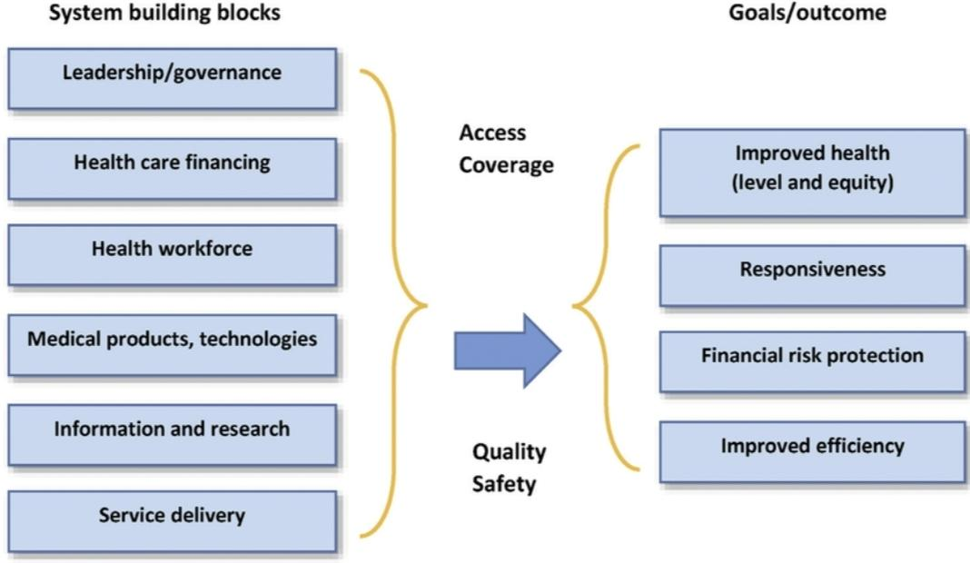

**Developing a disaster recovery plan with IBM Cloud Virtual Servers offers several key uses and benefits for businesses:**

1. **Data Protection**: Safeguard critical data by creating redundant copies and ensuring data integrity in the event of hardware failures, data corruption, or disasters.

2. **Business Continuity**: Ensure uninterrupted operations even in the face of unexpected disruptions, minimizing downtime and maintaining customer confidence.

3. **High Availability:** Leverage IBM Cloud's infrastructure to create a secondary site that can quickly take over operations in the event of a failure in the primary data center.

4. **Cost Efficiency:** IBM Cloud's pay-as-you-go pricing model allows you to only pay for resources when needed, reducing capital expenses associated with traditional disaster recovery infrastructure.

5. **Scalability**: Easily adjust your disaster recovery infrastructure to meet changing business needs, whether it's scaling up or down.

6. **Security:** Utilize IBM Cloud's security features, including encryption, access controls, and network isolation, to enhance data protection.

7. **Global Reach:**

IBM Cloud has data centers in various regions, enabling you to replicate data and applications across geographic locations for added resilience.

8. **Automation**:

Implement automated failover and failback processes to minimize manual intervention during disaster recovery scenarios.

***Disaster recovery involves a range of techniques and strategies to ensure that an organization can quickly and effectively recover from a disaster or significant disruption. Some common techniques include:***

1. **Data Backups:** Regularly backing up critical data and systems is fundamental. This can be done using techniques like full backups, incremental backups, and differential backups. Storing backups both on-site and off-site is crucial.

2**. Redundancy:**

Implement redundancy in critical systems. This can include redundant servers, network connections, and power sources. Redundancy helps maintain service availability in case of hardware failures.

3. **Disaster Recovery Plan (DRP):**

Develop a comprehensive DRP that outlines the procedures, roles, and responsibilities in the event of a disaster. Test the plan regularly to ensure its effectiveness.

4. **Virtualization**: Using virtualization technologies allows for quick deployment of backup systems and applications in case of a disaster. Virtual machines can be more easily replicated and moved to alternative locations.

5. **Cloud-Based Services:**

Leveraging cloud services for data storage and application hosting can enhance disaster recovery. Many cloud providers offer built-in redundancy and disaster recovery features.

6. **Off-Site Locations:**

Storing backups and critical data at geographically distant off-site locations ensures that data is safe in case of a localized disaster.

7. **High Availability (HA) Clusters:**

Deploying high availability clusters can ensure system availability by automatically shifting workloads to healthy nodes in the event of a failure.

8. **Data Mirroring:**

Data mirroring involves duplicating data in real-time on separate storage systems. This ensures data consistency and availability.

9. **Testing and Simulation:**

Regularly testing disaster recovery plans through simulations and drills helps identify weaknesses and improve the recovery process.

10. **Documentation**:

Maintain detailed documentation of system configurations, procedures, and recovery steps. This can be invaluable during a disaster.

11. **Communication Plans:**

Establish communication plans to keep stakeholders informed during a disaster. This includes employees, customers, and relevant authorities.

12. **Security Measures:**

Implement security measures to protect data during recovery, such as encryption and access controls.

13. **Risk Assessment:**

Continuously assess potential risks and update the disaster recovery plan accordingly.

14. **Vendor Support:**

For third-party applications and services, ensure you have a clear understanding of vendor support and disaster recovery options.

15. **Employee Training:**

Train employees on their roles and responsibilities in the event of a disaster, and ensure they understand the recovery procedures.

The specific techniques and strategies a business employs will depend on its unique requirements, budget, and the criticality of its systems and data.

